Table of Contents

Certificate 2
Declaration 3
Table of Contents 4
Chapter 1 - Introduction 7
  - Project Overview 7
  - Purpose of the System 7
  - Scope of the Project 7
  - Objectives 7
  - Intended Users 7
  - Definitions, Acronyms and Abbreviations 8
  - References 8
Chapter 2 - Overall Description 9
  - Product Perspective 9
  - Product Functions 9
  - User Classes 9
  - Operating Environment 9
  - Design and Implementation Constraints 10
  - Assumptions and Dependencies 10
Chapter 3 - Functional Requirements 11
  - Authentication 11
  - User Management 11
  - Ask Sahayak - AI Assistant (Main Module) 11
  - Digital Learning 11
  - Progress Tracking and Reports 12
  - Scam Awareness (Safety) 12
  - Feedback 12
  - Notifications 12

Chapter 4 - Non-Functional Requirements 13
  - Performance 13
  - Security 13
  - Usability 13
  - Reliability 13
  - Availability 13
  - Maintainability 13
  - Scalability 13
  - Portability 13
Chapter 5 - External Interface Requirements 14
  - User Interface 14
  - Hardware Interface 14
  - Software Interface 14
  - Communication Interface 14
Chapter 6 - Use Case Requirements 15
  - Actors 15
  - Use Case Diagram 15
  - Use Case Descriptions 15
Chapter 7 - System Models 19
  - System Architecture 19
  - Context Diagram (Level 0) 19
  - Data Flow Diagram (Level 1) 20
  - Activity Diagram 21
  - Sequence Diagram 22
  - Class Diagram 23
  - Entity-Relationship Diagram 24
Chapter 8 - Data Requirements 26
  - Database Tables 26
  - Data Dictionary 26
Chapter 9 - System Constraints 28
Chapter 10 - Acceptance Criteria 29
Chapter 11 - Requirements Traceability Matrix 30
Chapter 12 - Appendices 31
Appendix A - Glossary 31
Appendix B - API Endpoints (Planned) 31
Appendix C - Development Roadmap 31
Appendix D - References 32

Chapter 1 - Introduction

Project Overview

Sahayak AI is a web-based digital assistance and literacy platform that helps elderly and non-tech-savvy users operate everyday digital services with confidence. The user asks a technology-related question in plain language, by typing or speaking, and Sahayak AI returns short, step-by-step guidance that matches the user's language and level of technical skill. The platform also supports screenshot understanding, a structured digital learning module, progress tracking, and awareness of common online scams.

Unlike a general chatbot, Sahayak AI adapts every answer to a stored user profile - the preferred language, a beginner or experienced skill level, and past learning history - so the same question produces a different explanation for a first-time smartphone user and for a confident user.

Purpose of the System

A large share of the population is excluded from digital services not because the services are unavailable, but because the interfaces are hard to use. Small buttons, technical terminology, English-only text, and unclear error messages make routine tasks such as sending a WhatsApp photo, paying by UPI, or reading an email feel risky. Sahayak AI is being developed to remove that barrier by acting as a patient, always-available digital helper that speaks the user's language and explains each step simply.

Scope of the Project

The system covers the following in its first release and planned extensions:
    - User registration, secure login, and profile management with language and skill level.
    - Text-based 'Ask Sahayak' assistance that returns simple, step-by-step instructions.
    - Multilingual answers in English, Hindi, and Marathi.
    - An elder-friendly dashboard with large text, large buttons, and minimal menus.
    - Voice input (speech-to-text) and voice output (text-to-speech).
    - Screenshot understanding - the user uploads an image and Sahayak explains what to do.
    - A digital learning module with structured topics and quizzes.
    - Learning progress tracking with a Digital Confidence score.
    - Scam and suspicious-message awareness with educational warnings.
    - A feedback mechanism attached to every AI response.

The following are explicitly outside the current scope:
    - Automatic control of the user's device screen or remote operation of apps.
    - Guaranteed fraud detection - the safety module gives educational warnings, not verdicts.
    - Processing of real financial transactions, payments, or banking operations.
    - Support for languages beyond English, Hindi, and Marathi in the first version.
    - Native mobile applications for Android or iOS (the first release is a responsive web app).

Objectives
- To let a non-technical user get a clear, correct answer to a digital question in under three steps.
- To adapt every explanation to the user's language and skill level.
- To reduce the time a user needs to complete a common digital task.
- To raise measurable digital confidence through a structured learning module.
- To warn users about common online scams such as OTP and PIN requests.
- To provide a simple interface usable by users with limited vision and limited English.

Intended Users
- <b>Elderly / non-tech-savvy user</b> - the primary user who asks questions, learns, and checks messages.
- <b>Intermediate learner</b> - a user with some digital familiarity who uses the learning module and progress view.
- <b>Administrator</b> - manages learning content, tutorials, and user accounts.

Definitions, Acronyms and Abbreviations

Term | Meaning
SRS | Software Requirements Specification
AI | Artificial Intelligence
LLM | Large Language Model
MVP | Minimum Viable Product
UI / UX | User Interface / User Experience
API | Application Programming Interface
REST | Representational State Transfer
JWT | JSON Web Token
DB | Database
UPI | Unified Payments Interface
OTP | One-Time Password
DFD | Data Flow Diagram
ER | Entity-Relationship
RTM | Requirements Traceability Matrix
Skill level | The user's stated comfort with technology (BEGINNER / INTERMEDIATE / EXPERIENCED)

References
    - IEEE Std 830-1998 - IEEE Recommended Practice for Software Requirements Specifications.
    - Spring Boot Reference Documentation, VMware Tanzu - https://spring.io/projects/spring-boot
    - React Documentation, Meta Open Source - https://react.dev
    - Oracle MySQL 8.0 Reference Manual - https://dev.mysql.com/doc/
    - Google AI (Gemini API) Developer Documentation - https://ai.google.dev
    - OWASP Application Security Verification Standard (ASVS), v4.0.
    - Web Content Accessibility Guidelines (WCAG) 2.1, W3C.

Chapter 2 - Overall Description

Product Perspective

Sahayyak AI is a new, self-contained system rather than an extension of an existing product. It replaces the informal help a user currently receives from family members or trial-and-error use of applications. The system is delivered as a responsive web application: a React frontend in the browser, a Spring Boot backend exposing REST APIs, a MySQL relational database for persistence, and an external large language model service (Gemini) for generating and understanding content.

Product Functions

The main functions of the system are summarised below.

Module | Primary Function
Authentication | Register, log in, log out; secure session via JWT.
Dashboard | Elder-friendly home screen with large categories and voice button.
Ask Sahayak | Answer a typed, spoken, or screenshot-based question with simple steps.
Personalization | Adapt answers using language, skill level, and learning history.
Language | Deliver answers in English, Hindi, or Marathi.
Voice Assistant | Speech-to-text input and text-to-speech output.
Screenshot Assistant | Explain buttons, icons, warnings, and menus from an image.
Digital Learning | Structured topics with guided tutorials and quizzes.
Progress Tracking | Record topic completion and compute a Digital Confidence score.
Scam Awareness | Analyse a suspicious message or screenshot and give safety warnings.
Feedback | Collect a rating and reason after every AI response.

User Classes

User Class | Responsibilities / Use
Elderly / Non-Tech User | Asks questions, follows instructions, learns topics, checks messages.
Intermediate Learner | Uses the learning module, tracks progress, gives feedback.
Administrator | Manages tutorials and learning content, monitors users and feedback.
AI Service (external) | Generates answers and interprets screenshots on request.

Operating Environment

Hardware (client):
    - Processor: dual-core 1.5 GHz or higher.
    - RAM: 2 GB minimum (4 GB recommended).
    - Storage: 200 MB free space for the browser.
    - Internet: broadband or mobile data connection.
    - Microphone and camera (optional, for voice and screenshot capture).

Software:

Component | Technology
Frontend | React.js, HTML5, CSS3, JavaScript, Tailwind CSS, React Router
Backend | Java 17, Spring Boot, Spring Web, Spring Data JPA, Spring Security, Maven
Database | MySQL 8.0
AI Service | Gemini API (large language and multimodal model)
Browser | Chrome, Edge, or Firefox (latest versions)
Operating System | Windows / Linux / macOS (client and server)
Deployment | Frontend on Vercel; backend on a cloud host; managed cloud MySQL

Design and Implementation Constraints
    - The system must use a relational database (MySQL) for all persistent data.
    - Only authenticated users may access the dashboard and assistant features.
    - Passwords must never be stored as plain text; they must be hashed.
    - Session and API access must be protected with JWT and role-based authorization.
    - The application must run on modern browsers without a separate installation.
    - The backend must expose functionality only through documented REST APIs.
    - AI answers must be generated through an external model service and are subject to its availability.

Assumptions and Dependencies
    - Users have a working internet connection and a modern browser.
    - Users have a valid registered account and can recall their credentials.
    - The MySQL database server is available whenever the backend runs.
    - The Gemini (or equivalent LLM) API is available and within its usage quota.
    - Users enter questions in one of the supported languages, or use voice input.
    - User profile information (language, skill level) is entered correctly at registration.

Chapter 3 - Functional Requirements

Functional requirements are grouped by module. Each requirement carries a unique identifier (FR-nn) used later in the traceability matrix.

Authentication

ID | Requirement
FR-01 | The system shall allow a new user to register with name, email, password, language, and skill level.
FR-02 | The system shall validate the email format and enforce a minimum password strength.
FR-03 | The system shall store passwords as a secure hash, never as plain text.
FR-04 | The system shall allow a registered user to log in with email and password.
FR-05 | The system shall issue a JWT on successful login and reject invalid credentials with a clear message.
FR-06 | The system shall allow the user to log out and invalidate the active session.

User Management

ID | Requirement
FR-07 | The system shall display the logged-in user's profile on request.
FR-08 | The system shall allow the user to update name, language, and skill level.
FR-09 | The system shall store the user's preferred language and skill level as part of the profile.
FR-10 | The administrator shall be able to view and deactivate user accounts.

Ask Sahayak - AI Assistant (Main Module)

ID | Requirement
FR-11 | The system shall accept a technology-related question entered as text.
FR-12 | The system shall build an AI prompt that includes the question, the user's language, and the skill level.
FR-13 | The system shall request an answer from the AI service and return it to the user as numbered steps.
FR-14 | The system shall keep answers simple, avoid technical terminology, and explain unfamiliar icons.
FR-15 | The system shall store each question and its response for history and personalization.
FR-16 | The system shall accept voice input and convert speech to text before processing.
FR-17 | The system shall read out the answer using text-to-speech when voice output is enabled.
FR-18 | The system shall accept an uploaded screenshot and return an explanation of what to do.
FR-19 | The system shall present quick category shortcuts (Mobile and Apps, WhatsApp, Digital Payments, Email).

Digital Learning

ID | Requirement
FR-20 | The system shall present learning topics grouped into at least five categories.
FR-21 | The system shall display tutorial content for a selected topic, step by step.
FR-22 | The system shall mark a topic complete when the user finishes its tutorial and quiz.
FR-23 | The system shall record a score for each completed quiz.

Progress Tracking and Reports

ID | Requirement
FR-24 | The system shall compute and display a Digital Confidence score per user.
FR-25 | The system shall display progress per topic as a percentage or bar.
FR-26 | The system shall record the date a topic was last accessed.
FR-27 | The administrator shall be able to view aggregate usage and feedback reports.

Scam Awareness (Safety)

ID | Requirement
FR-28 | The system shall accept a suspicious message or screenshot for analysis.
FR-29 | The system shall identify common warning signs such as OTP, PIN, or password requests.
FR-30 | The system shall display an educational safety warning without claiming guaranteed fraud detection.

Feedback

ID | Requirement
FR-31 | The system shall ask the user whether each AI response was helpful.
FR-32 | The system shall collect a reason when a response is marked not helpful (too difficult, too long, wrong language, still unclear).
FR-33 | The system shall store feedback linked to the corresponding question.

Notifications

ID | Requirement
FR-34 | The system shall show a friendly in-app message when an error occurs, in the user's language.
FR-35 | The system shall notify the user when a learning topic is completed or a score changes.

Chapter 4 - Non-Functional Requirements

Performance
    - The system shall respond to a normal UI request within 3 seconds under expected load.
    - A text question shall return an AI answer within 8 seconds under normal network conditions.
    - The system shall support at least 100 concurrent users in the first release.

Security
    - Passwords shall be stored using a strong one-way hash (for example, BCrypt).
    - All traffic between client and server shall use HTTPS.
    - API endpoints shall be protected by JWT authentication and role-based authorization.
    - A user shall not be able to read or modify another user's data.
    - Uploaded screenshots shall be processed transiently and not exposed publicly.

Usability
    - The interface shall use large fonts, large touch targets, and high colour contrast.
    - Every screen shall require a minimal number of steps to reach a task.
    - Error and permission messages shall be explained in plain, non-technical language.
    - The interface shall support the user's selected language throughout.
    - Voice input shall be available wherever text input is required.

Reliability
    - The system shall maintain data consistency across user, question, and progress records.
    - The system shall handle unexpected errors gracefully and never show raw error dumps to the user.
    - Database backups shall be supported at regular intervals.

Availability
    - The system shall target 99% availability during daytime hours.
    - When the AI service is temporarily unavailable, the system shall show a clear retry message.

Maintainability
    - The backend shall follow a layered structure (controller, service, repository, entity).
    - The frontend shall separate components, pages, and services.
    - Code shall be documented and version-controlled.
    - A change in one module shall have minimal impact on other modules.

Scalability
    - The system shall support a growing number of users, questions, and learning records without architectural change.
    - The AI service layer shall be replaceable or upgradable without changing the frontend.

Portability
    - The web application shall operate on commonly used modern browsers (Chrome, Edge, Firefox).
    - The application shall be usable on both desktop and mobile screen sizes.

Chapter 5 - External Interface Requirements

User Interface

The system provides the following screens. Wireframes and screenshots will be added in the final report.
    - Login page and Registration page.
    - Elder-friendly Dashboard with a greeting, a voice button, and large category buttons.
    - Ask Sahayak page (text, voice, and screenshot input with a chat-style answer area).
    - Learning page listing topics and tutorial content.
    - Progress page showing per-topic progress and the Digital Confidence score.
    - Scam Check page for uploading or pasting a suspicious message.
    - Profile page for language and skill level settings.

Hardware Interface
    - Microphone - for capturing voice input.
    - Camera or file system - for capturing or selecting screenshots.
    - Speaker or headphones - for voice output.

Software Interface

External System | Interface Purpose
MySQL database | Persistent storage of users, questions, progress, feedback, and content.
Gemini API (LLM) | Generation of text answers and interpretation of screenshots.
Web Speech API / speech service | Speech-to-text and text-to-speech.
Cloud hosting services | Deployment of frontend, backend, and database.

Communication Interface
    - HTTPS for all client-server communication.
    - REST APIs exchanging JSON payloads.
    - TCP/IP as the underlying transport.
    - Standard browser APIs for microphone and file upload.

Chapter 6 - Use Case Requirements

Actors

Actor | Description
Elderly / Non-Tech User | Primary actor; asks questions, learns, checks messages, gives feedback.
Administrator | Manages users, tutorials, and content; views reports.
AI Service (Gemini) | Secondary actor; returns generated answers and image explanations.

Use Case Diagram
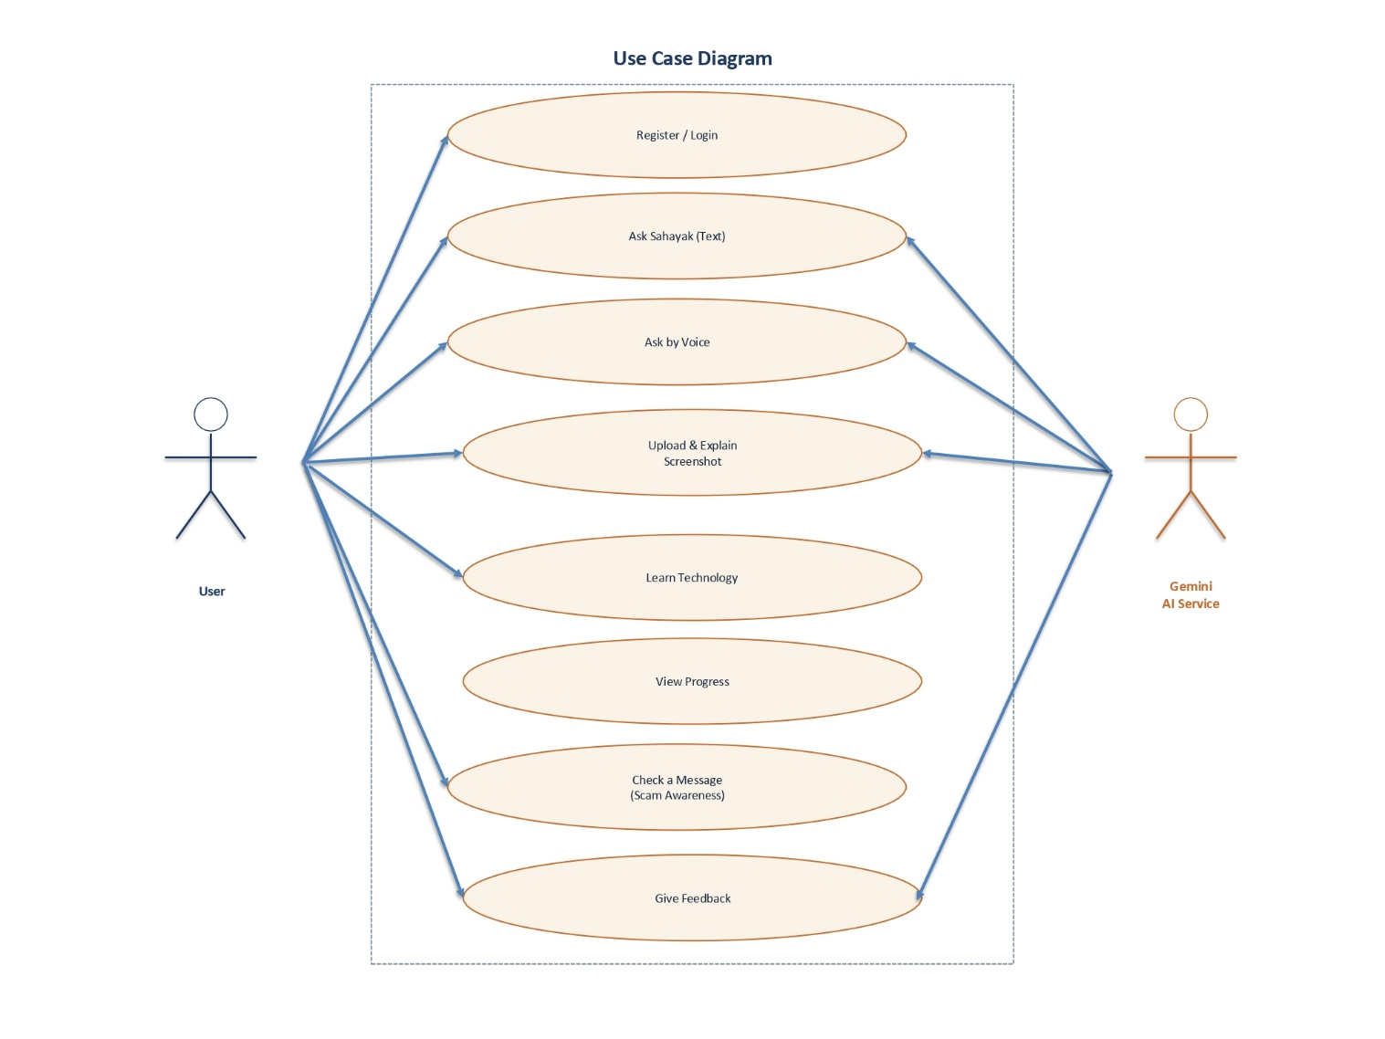

Figure 6.1 - Use Case Diagram of Sahayak AI.

Use Case Descriptions

Field | Description
Use Case ID | UC-01
Use Case | Register
Actor | User
Precondition | User is not yet registered
Main Flow | Open registration form -> enter name, email, password, language, skill level -> submit -> account created
Alternative Flow | Invalid email or weak password -> show validation message
Postcondition | New account stored; user can log in

Field | Description
Use Case ID | UC-02
Use Case | Login
Actor | User
Precondition | User is registered
Main Flow | Enter email and password -> validate credentials -> issue JWT -> open dashboard
Alternative Flow | Invalid credentials -> display error message
Postcondition | User is logged in and sees the dashboard

Field | Description
Use Case ID | UC-03
Use Case | Ask Sahayak (Text)
Actor | User
Precondition | User is logged in
Main Flow | Open Ask Sahayak -> type question -> send to backend -> backend builds prompt -> AI returns answer -> display steps
Alternative Flow | AI service unavailable -> show retry message
Postcondition | Answer displayed and stored in history

Field | Description
Use Case ID | UC-04
Use Case | Ask by Voice
Actor | User
Precondition | User is logged in and microphone is available
Main Flow | Tap voice button -> speak -> speech converted to text -> processed as a question -> answer spoken and shown
Alternative Flow | Speech not recognised -> ask the user to try again
Postcondition | Answer delivered as text and voice

Field | Description
Use Case ID | UC-05
Use Case | Upload and Explain Screenshot
Actor | User, AI Service
Precondition | User is logged in
Main Flow | Upload screenshot -> attach question -> backend sends image to AI -> AI explains what to do -> display explanation
Alternative Flow | Unsupported image format -> show error
Postcondition | Explanation displayed to the user

Field | Description
Use Case ID | UC-06
Use Case | Learn Technology
Actor | User
Precondition | User is logged in
Main Flow | Open Learning -> choose a category -> read tutorial steps -> attempt quiz -> topic marked complete
Alternative Flow | Quiz not completed -> progress not incremented
Postcondition | Progress and score updated

Field | Description
Use Case ID | UC-07
Use Case | View Progress
Actor | User
Precondition | User is logged in
Main Flow | Open Progress -> system reads learning records -> compute Digital Confidence -> display bars
Alternative Flow | No learning activity -> display zero progress
Postcondition | Progress view shown

Field | Description
Use Case ID | UC-08
Use Case | Check a Message
Actor | User, AI Service
Precondition | User is logged in
Main Flow | Open Scam Check -> paste message or upload screenshot -> backend analyses -> display warning
Alternative Flow | Message unreadable -> ask for a clearer input
Postcondition | Safety warning displayed

Field | Description
Use Case ID | UC-09
Use Case | Give Feedback
Actor | User
Precondition | An AI response has been shown
Main Flow | Rate response -> optionally choose a reason -> submit -> feedback stored
Alternative Flow | No rating selected -> prompt to choose
Postcondition | Feedback saved against the question

Field | Description
Use Case ID | UC-10
Use Case | Manage Content
Actor | Administrator
Precondition | Administrator is logged in
Main Flow | Open admin view -> add or edit tutorials -> save -> content available to users
Alternative Flow | Invalid content -> show validation error
Postcondition | Content updated in the database

Chapter 7 - System Models

This chapter presents the system models that describe the structure and behaviour of Sahayak AI. The architecture diagram is included first, followed by the standard models.

System Architecture
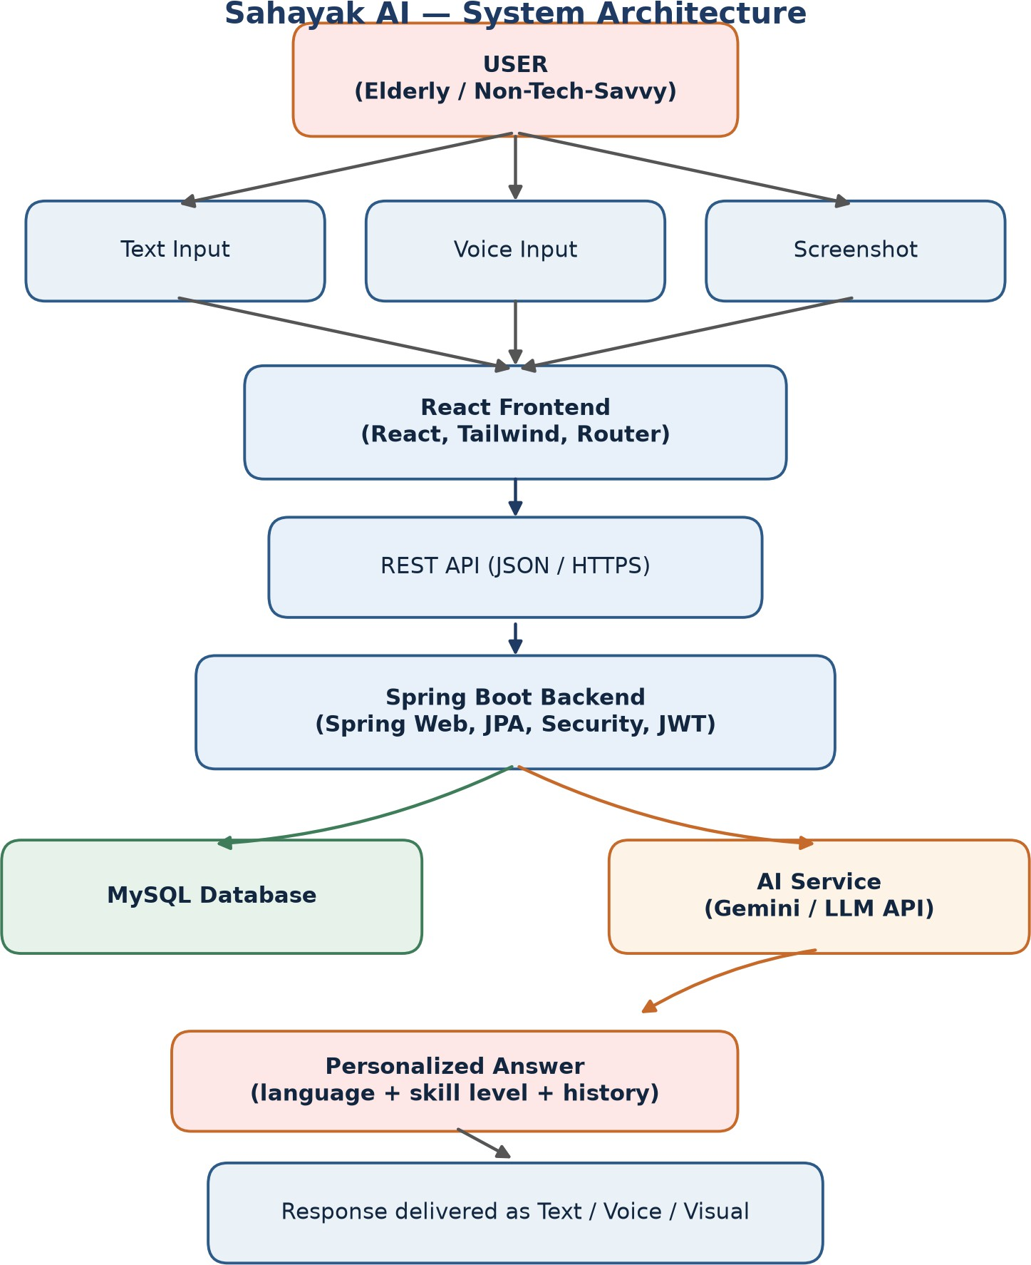

Figure 7.1 - Overall system architecture of Sahayak AI.

Context Diagram (Level 0)

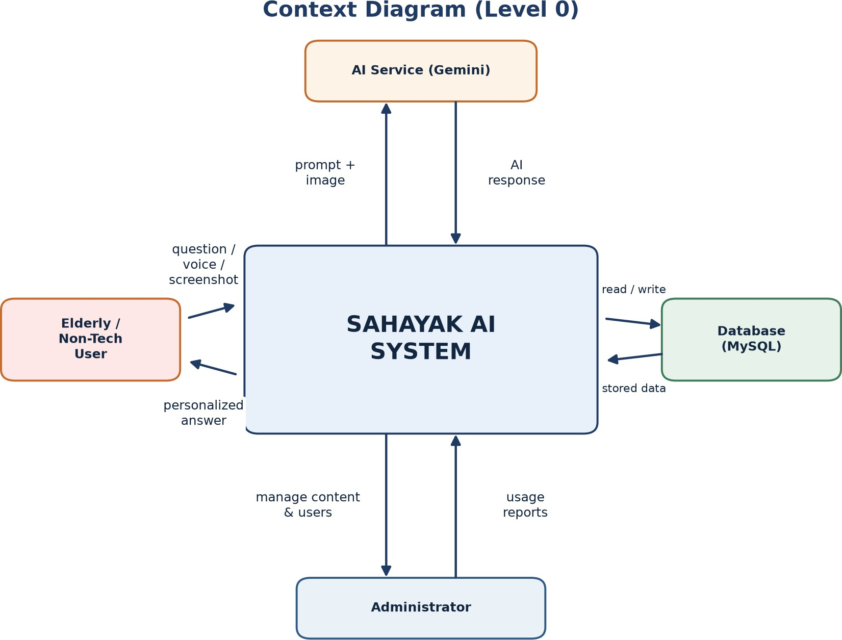

Figure 7.2 - Context diagram showing external entities and data flows.

Data Flow Diagram (Level 1)

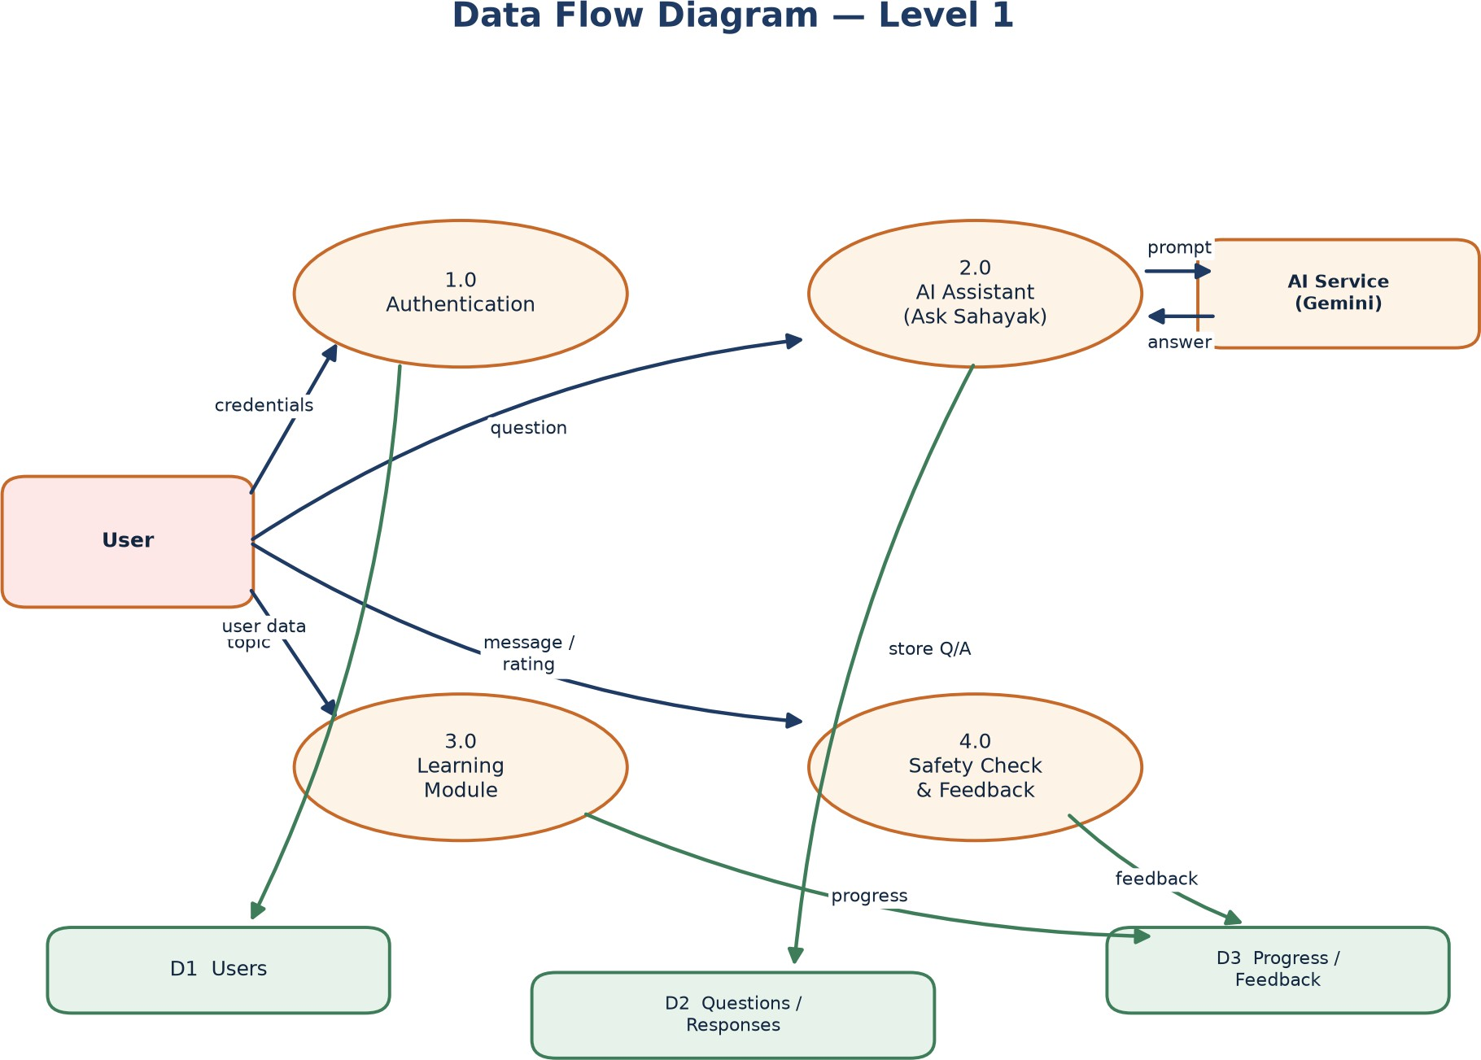

Activity Diagram –

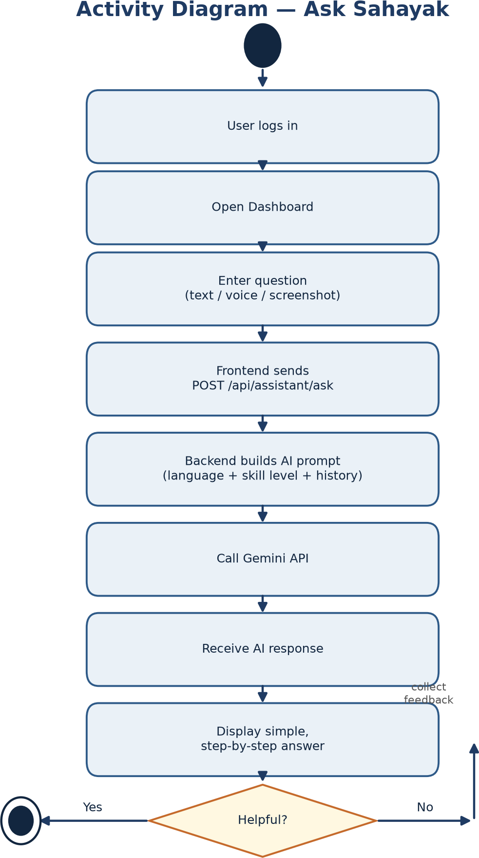

Figure 7.4 - Activity diagram for the Ask Sahayak flow.

Sequence Diagram

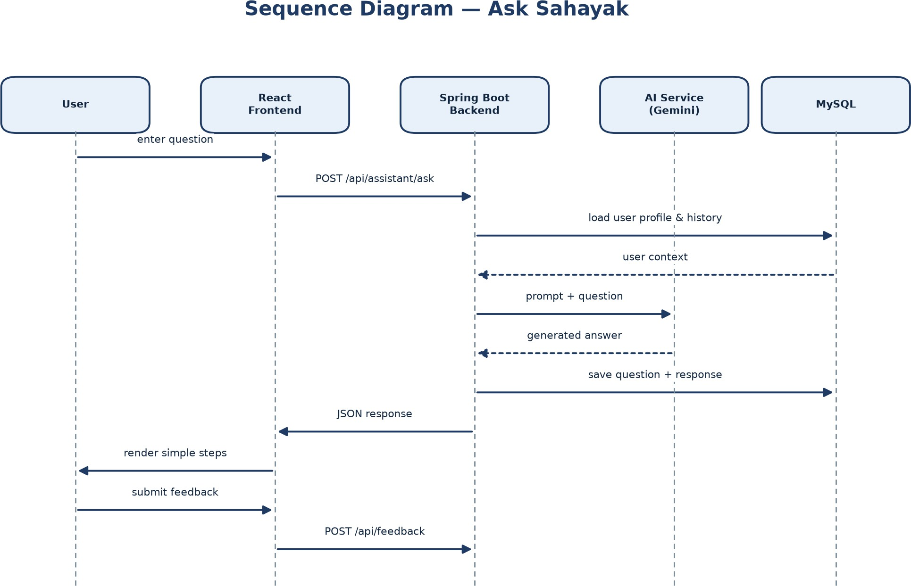

Figure 7.5 - Sequence diagram for a question-answer interaction.

Class Diagram

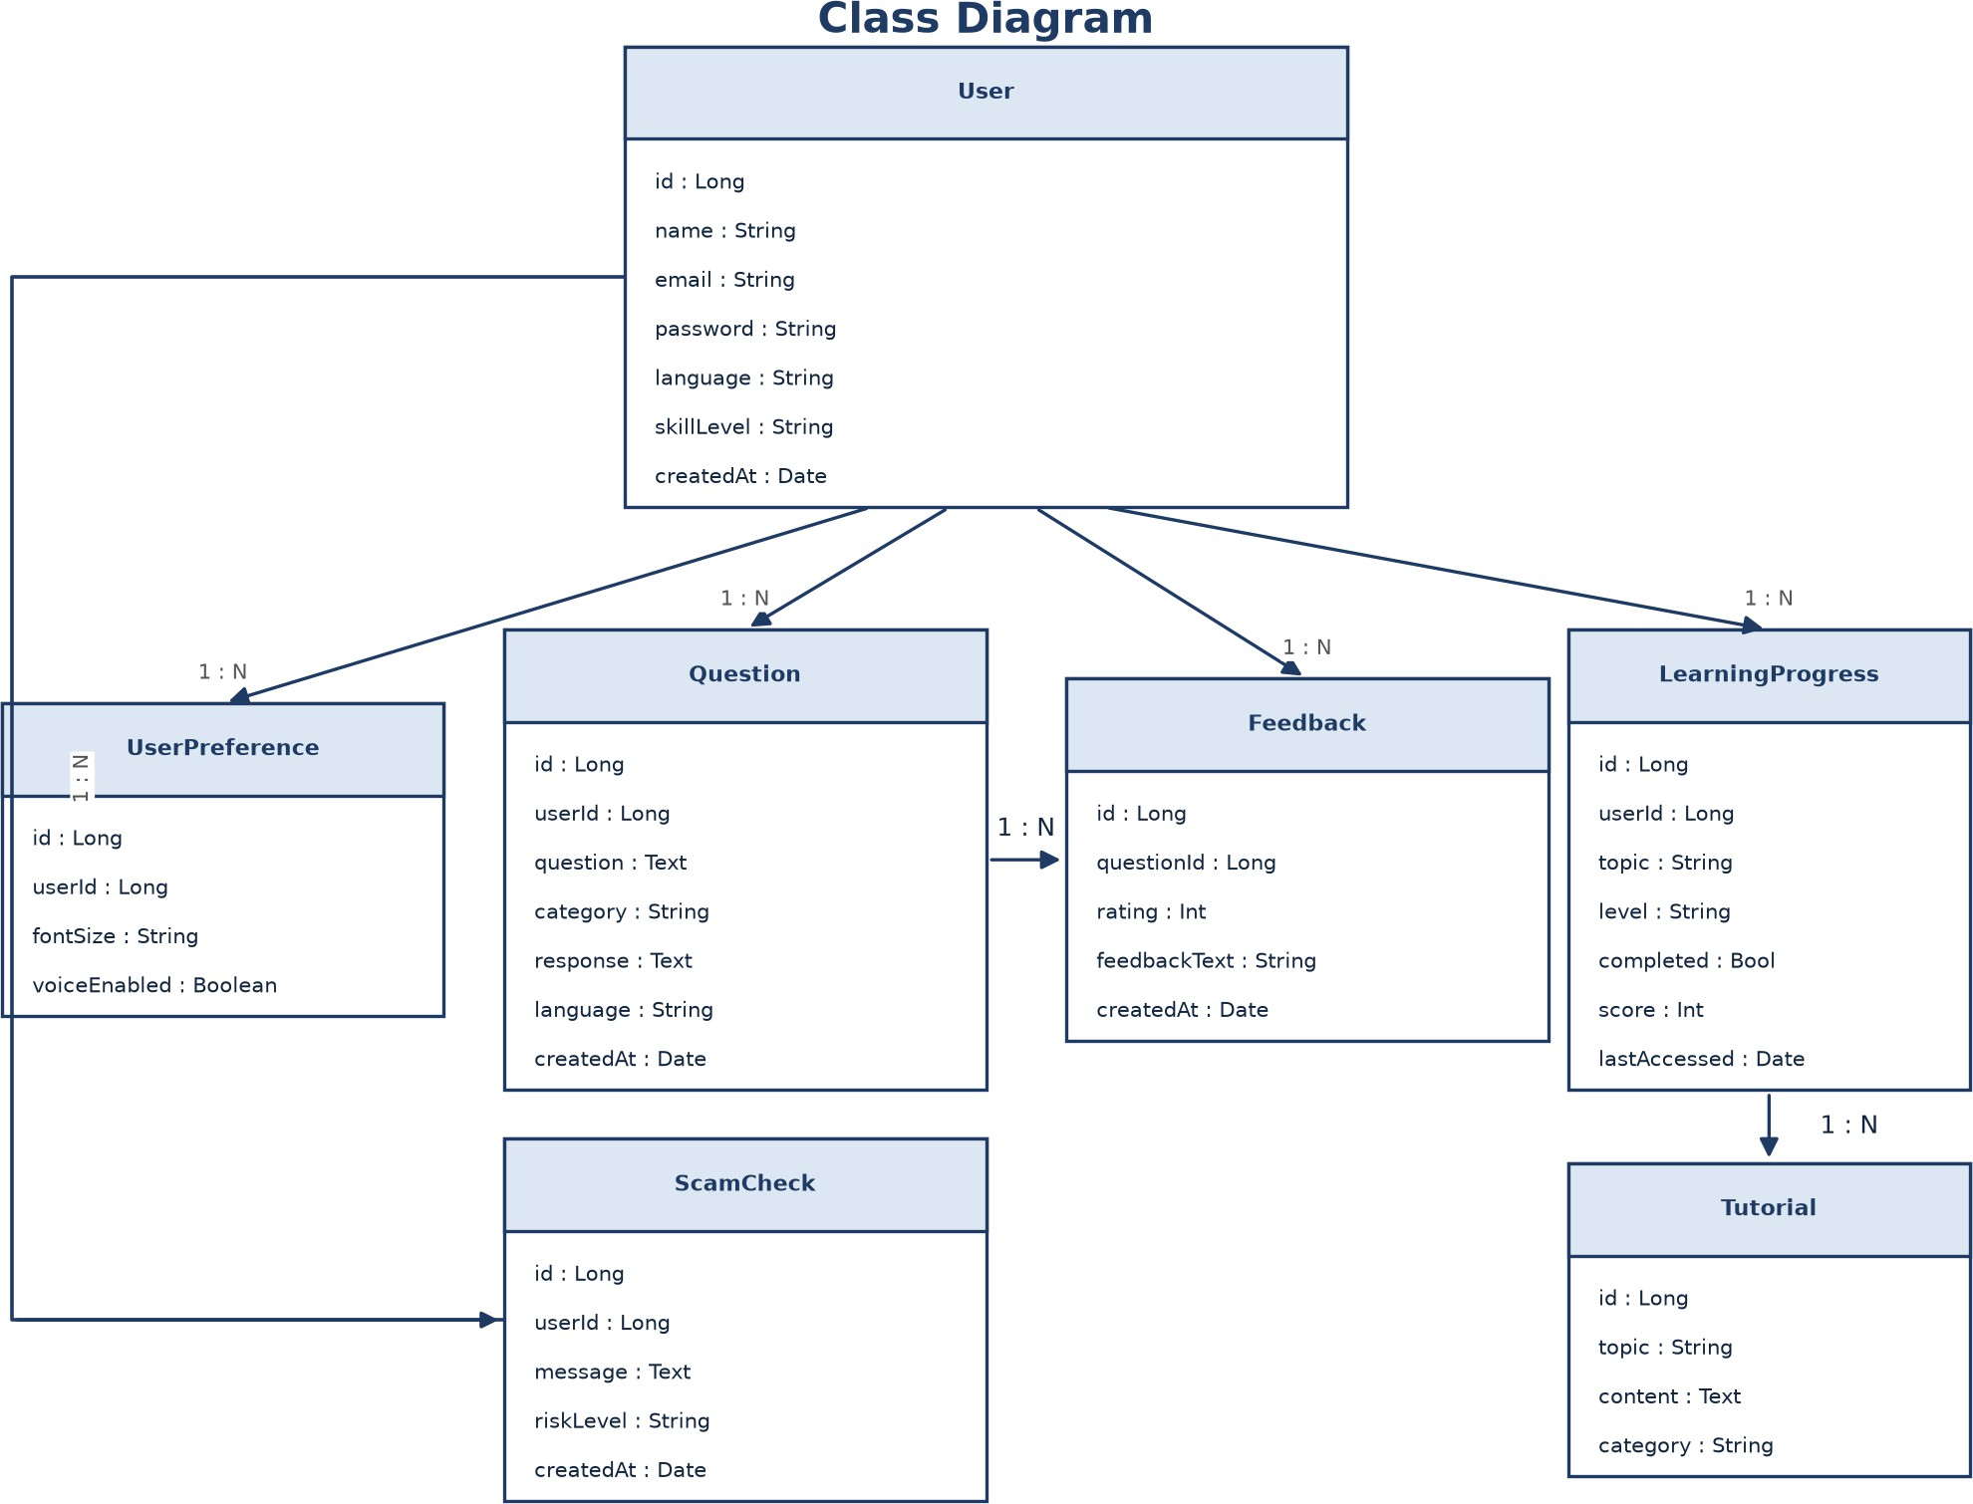

Figure 7.6 - Class diagram of the Sahayak AI domain model.

Entity-Relationship Diagram

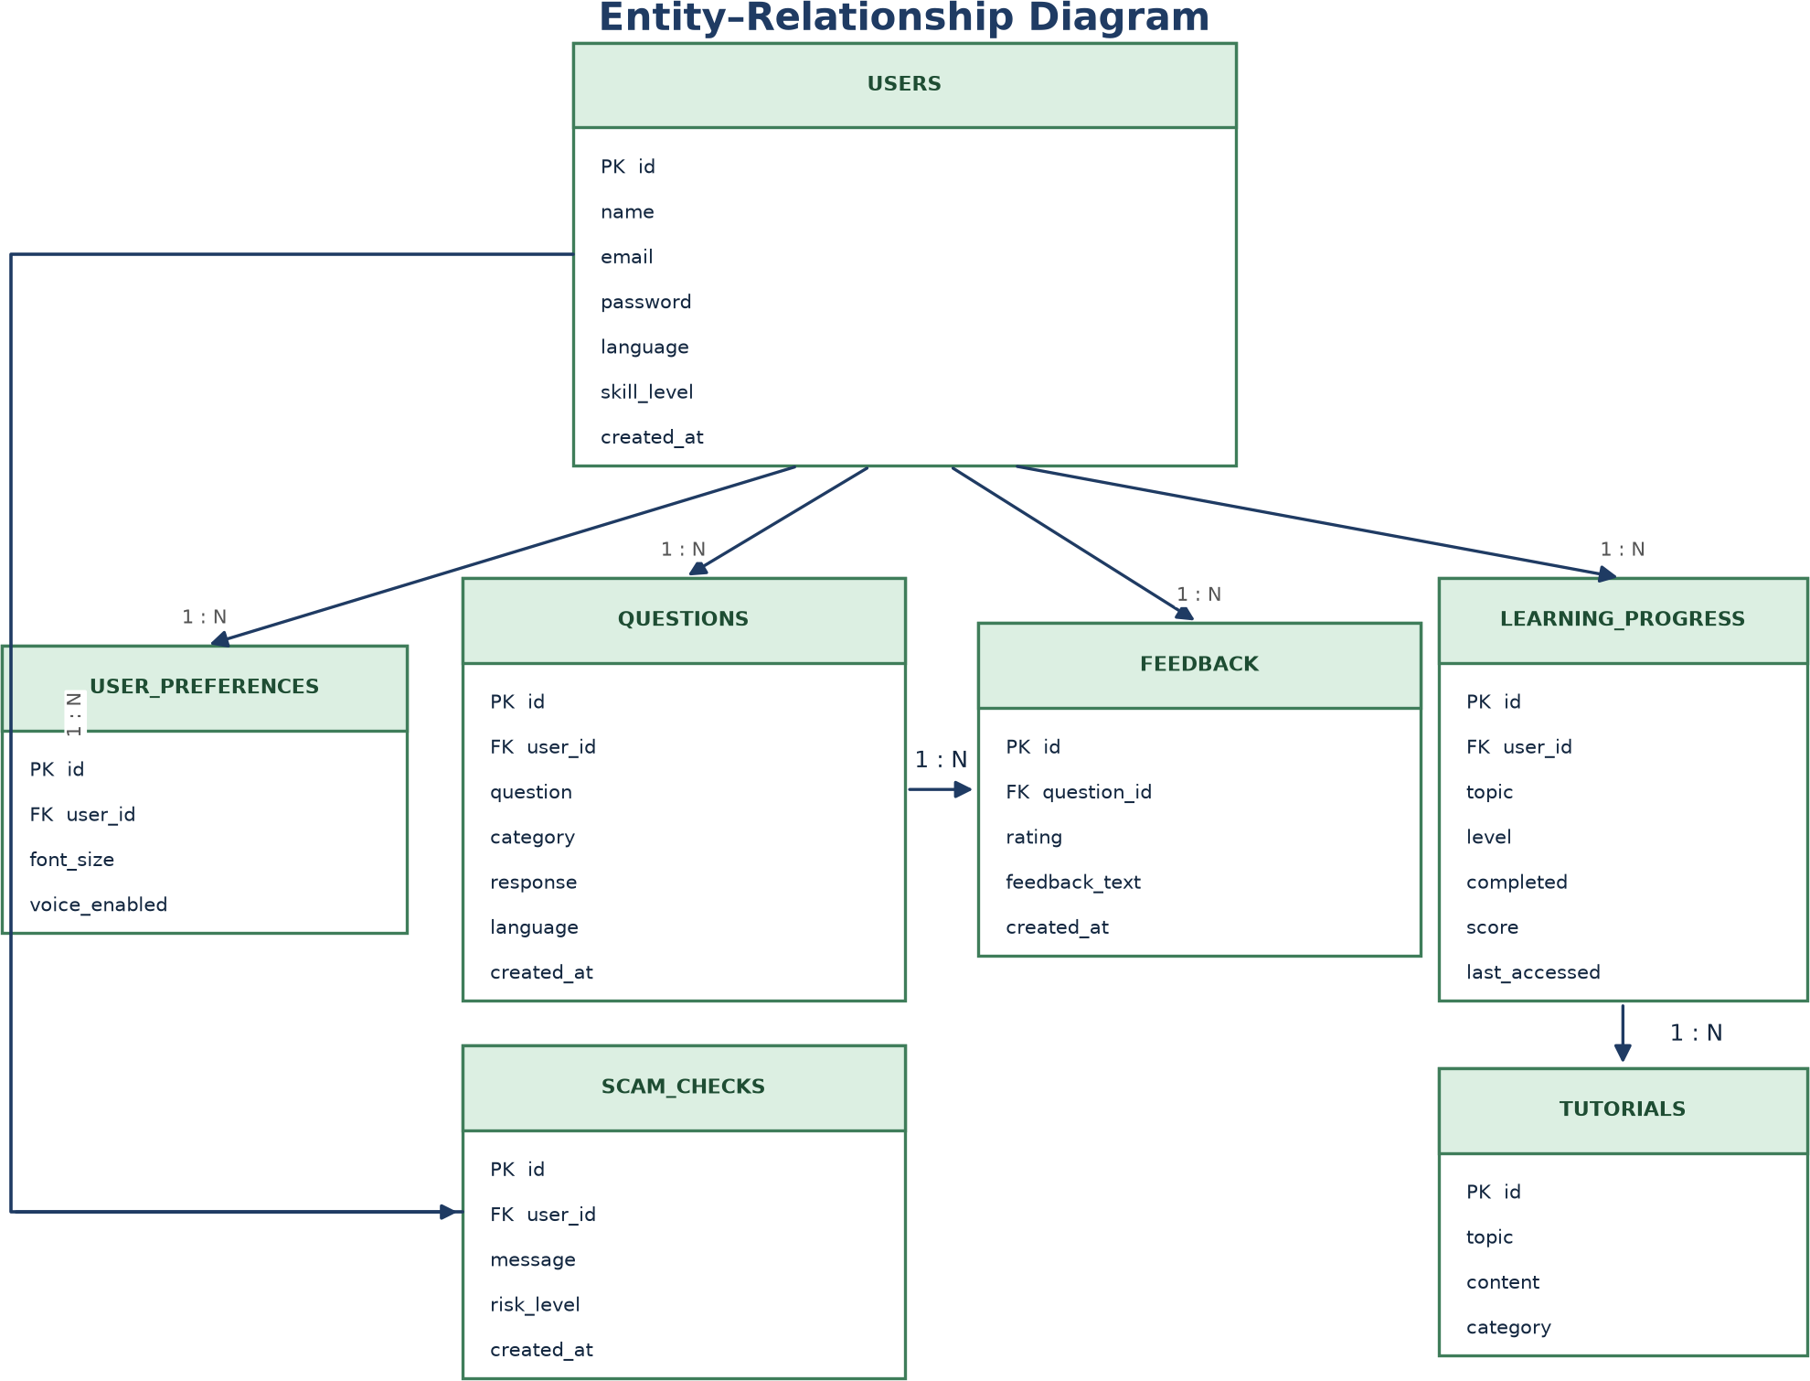

Figure 7.7 - Entity-Relationship diagram of the database.

Chapter 8 - Data Requirements

Database Tables

The system uses the following tables in a MySQL database. The users table is the parent of most other tables.

Table | Purpose
users | Registered user accounts and profile.
user_preferences | Accessibility and interface preferences per user.
questions | Questions asked and the responses returned.
learning_progress | Topic-level completion and score per user.
feedback | Helpfulness rating and reason per response.
tutorials | Learning content for each topic and category.
scam_checks | Submitted suspicious messages and their risk level.

Data Dictionary

Users

Field | Data Type | Description
id | BIGINT (PK) | Unique user identifier
name | VARCHAR(100) | Full name of the user
email | VARCHAR(150) | Unique email used for login
password | VARCHAR(255) | Hashed password
language | VARCHAR(20) | Preferred language (English / Hindi / Marathi)
skill_level | VARCHAR(20) | BEGINNER / INTERMEDIATE / EXPERIENCED
created_at | DATETIME | Account creation timestamp

Questions

Field | Data Type | Description
id | BIGINT (PK) | Unique question identifier
user_id | BIGINT (FK) | Reference to users.id
question | TEXT | The question asked by the user
category | VARCHAR(60) | Topic category (e.g., WhatsApp, Payments)
response | TEXT | The AI-generated answer
language | VARCHAR(20) | Language of the question and answer
created_at | DATETIME | Timestamp of the question

Feedback

Field | Data Type | Description
id | BIGINT (PK) | Unique feedback identifier
question_id | BIGINT (FK) | Reference to questions.id
rating | INT | 1 = not helpful, 5 = very helpful
feedback_text | VARCHAR(255) | Reason when not helpful
created_at | DATETIME | Timestamp of feedback

Learning_Progress

Field | Data Type | Description
id | BIGINT (PK) | Unique record identifier
user_id | BIGINT (FK) | Reference to users.id
topic | VARCHAR(100) | Learning topic name
level | VARCHAR(20) | Difficulty level of the topic
completed | BOOLEAN | Whether the topic is completed
score | INT | Quiz score for the topic
last_accessed | DATETIME | Date the topic was last accessed

Tutorials

Field | Data Type | Description
id | BIGINT (PK) | Unique tutorial identifier
topic | VARCHAR(100) | Topic name
content | TEXT | Tutorial steps and explanation
category | VARCHAR(60) | Parent category of the topic

Scam_Checks

Field | Data Type | Description
id | BIGINT (PK) | Unique check identifier
user_id | BIGINT (FK) | Reference to users.id
message | TEXT | Submitted message or description
risk_level | VARCHAR(20) | LOW / MEDIUM / HIGH warning level
created_at | DATETIME | Timestamp of the check

User_Preferences

Field | Data Type | Description
id | BIGINT (PK) | Unique identifier
user_id | BIGINT (FK) | Reference to users.id
font_size | VARCHAR(20) | Preferred display font size
voice_enabled | BOOLEAN | Whether voice output is enabled

Chapter 9 - System Constraints
- Only registered and authenticated users can access the dashboard and assistant features.
- An internet connection is required because the AI service and database are hosted in the cloud.
- The system depends on the availability of the external AI service; answers cannot be generated without it.
- Only authorised administrators can modify learning content and user accounts.
- The system supports a predefined set of user roles and a fixed initial set of languages.
- Screenshot understanding depends on the quality of the uploaded image.
- The safety module provides educational warnings and does not guarantee fraud detection.

Chapter 10 - Acceptance Criteria

Each requirement is accepted only when its acceptance criterion is met. These criteria drive the system test cases.

Requirement | Acceptance Criterion
Registration (FR-01) | A valid form creates an account and the user can log in.
Login (FR-04) | Valid credentials open the dashboard; invalid credentials show an error.
Password security (FR-03) | The stored password value is a hash and never the plain text.
Ask Sahayak text (FR-11, FR-13) | A typed question returns numbered, simple steps in under 8 seconds.
Personalization (FR-12) | A beginner receives simpler steps than an experienced user for the same question.
Language (FR-09) | A Marathi-preference user receives the answer in Marathi.
Voice (FR-16, FR-17) | A spoken question is transcribed and the answer is read aloud.
Screenshot (FR-18) | An uploaded screenshot returns a correct explanation of the next action.
Learning (FR-22) | Finishing a tutorial and quiz marks the topic complete.
Progress (FR-24) | The Digital Confidence score updates after a topic is completed.
Safety (FR-29) | A message asking for an OTP is flagged with a warning.
Feedback (FR-31, FR-33) | A rating is stored and linked to the correct question.
Security (FR-06) | A logged-out or expired token cannot access protected APIs.
Role access (FR-10) | A normal user cannot access administrator functions.

Chapter 11 - Requirements Traceability Matrix

The matrix below links each functional requirement to its use case and planned test case, forming the chain: SRS -> Use Case -> Design -> Test Case.

Req. ID | Requirement | Use Case | Test Case
FR-01 | User registration | UC-01 | TC-01
FR-04 | User login | UC-02 | TC-02
FR-05 | Invalid credential handling | UC-02 | TC-03
FR-11 | Ask question by text | UC-03 | TC-04
FR-16 | Voice input | UC-04 | TC-05
FR-18 | Screenshot explanation | UC-05 | TC-06
FR-20 | Learning topics | UC-06 | TC-07
FR-22 | Topic completion | UC-06 | TC-08
FR-24 | Digital Confidence score | UC-07 | TC-09
FR-29 | Scam warning | UC-08 | TC-10
FR-31 | Response feedback | UC-09 | TC-11
FR-10 | Admin content management | UC-10 | TC-12
FR-03 | Password hashing | UC-01, UC-02 | TC-13
FR-26 | Last accessed tracking | UC-07 | TC-14

Chapter 12 - Appendices

Appendix A - Glossary

Term | Meaning
Sahayak | Hindi/Marathi word meaning 'helper' or 'assistant'.
Digital Confidence | A score representing a user's overall progress across learning topics.
Skill level | The user's stated comfort with technology.
MVP | The first working version containing only the core features.
Multimodal model | An AI model that can understand both text and images.

Appendix B - API Endpoints (Planned)

Area | Method and Endpoint | Purpose
Auth | POST /api/auth/register | Create a new account
Auth | POST /api/auth/login | Authenticate and issue JWT
User | GET /api/users/profile | Read the current user's profile
User | PUT /api/users/profile | Update profile settings
AI | POST /api/assistant/ask | Answer a text question
AI | POST /api/assistant/voice | Answer a spoken question
AI | POST /api/assistant/screenshot | Explain an uploaded screenshot
Learning | GET /api/learning/topics | List learning topics
Learning | GET /api/learning/{topic} | Get tutorial content
Learning | POST /api/learning/{topic}/complete | Mark a topic complete
Learning | GET /api/learning/progress | Read progress and confidence score
Safety | POST /api/safety/check | Analyse a suspicious message
Feedback | POST /api/feedback | Submit feedback for a response

Appendix C - Development Roadmap

Phase | Focus
Weeks 1-2 | Planning, requirements, UI design, database design
Weeks 3-4 | Spring Boot setup, MySQL, authentication, REST APIs
Week 5 | Connect AI service and get the first AI response
Week 6 | Personalization: language, skill level, prompt generation
Week 7 | Voice: speech-to-text and text-to-speech
Week 8 | Screenshot understanding and explanation
Week 9 | Learning module, progress, and confidence score
Week 10 | Safety module and scam warnings
Week 11 | Testing with real users across languages and skill levels
Week 12 | Deployment, documentation, and presentation preparation

Appendix D - References
- IEEE Std 830-1998, Recommended Practice for Software Requirements Specifications.
- Spring Boot, React, and MySQL official documentation.
- Google AI (Gemini API) documentation.
- WCAG 2.1 accessibility guidelines, W3C.

